Long Term Overview: The Reading Journey for Year 4 Theme Genre Author Cross Curricular
 | Autumn 1  7 weeks | Autumn 2  7 weeks | Spring 1  6 weeks | Spring 2  6 weeks | Summer 1  5 weeks | Summer 2  7 weeks
Theme | Journeys | Belief | Man vs Machine/  Acceptance  (Technology) | Heroes and Villain | Power | Animal Cruelty
 | Narrative: Own Myth  Non Chronological Report:  Mayan Information text | Narrative: setting description  Poetry | Narrative: Battle scene  Explanatory: how a machine works | Narrative: Historical (section) | Newspaper article: Electrigirl saves the day  Narrative: Alternative opening | Persuasion: Letter to ban bull fighting  Narrative: Atmosheric description with contrasting emotions
Writing Journey Text Driver: | 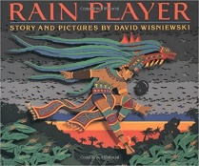  The Rain Player – David Wisniewski | 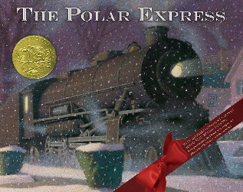  Polar Express  (book and film) | The Iron Man – Ted Hughes  Books – ‘Until I met Dudle’y &  ‘How Dogs Really Work’  Wallace & Gromit clips | 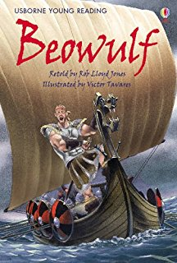  Beowulf  Jotun- Journey of a Viking  https://www.literacyshed.com/jotun.html | 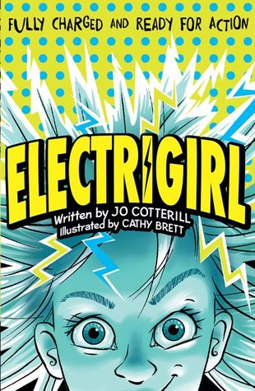  Electric Girl- Jo Cotterill | 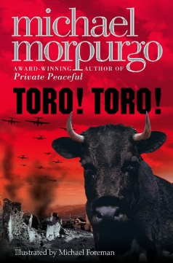  Toro Toro – Michael Morpurgo
Reading Journey | 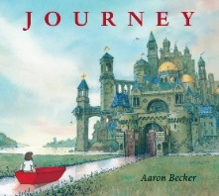  Journey – Aaron Baker  + Mayan Myths & Non-fiction texts/ articles | 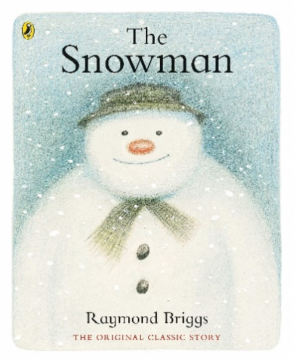  The Snowman by Raymond Briggs | + The Wild Robot by Peter Brown | 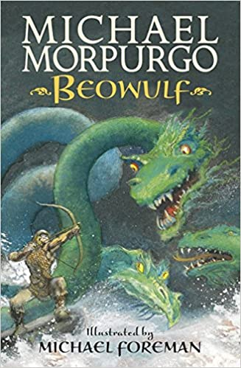  Different versions of Beowulf +  Nonfiction on Anglos Saxons & Vikings | 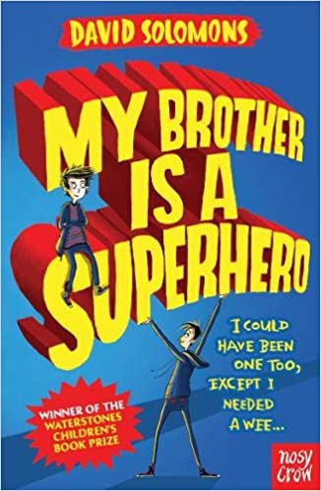  My Brother is a superhero  + articles on people with superhuman abilities  + Revision | 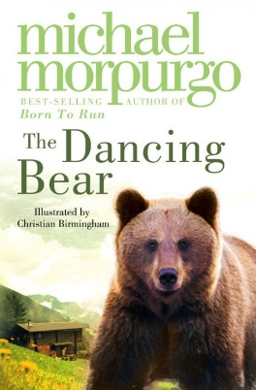  The Dancing Bear +  Non-Fiction texts on Spain/ Spanish culture  .

