Lesson 1  Why are these not sources of light?  The moon is not a light source because it does not make its own light.  We can see the moon because light from the sun reflects off it (bounces off it) back to the Earth.  The window is not a light source. It is an opening that lets the light from the sun or other light source into the room.  The mirror is not a source of light because it does not make its own light. It reflects light from other sources.  Dark is the absence of light. If there is no light source there will be no light and it will be dark. We cannot see in the dark | Lesson 2  Light Travels in a _______________ line.  When light hits an object it is ____________.  The brighter a colour, the (less / more) light is reflected.  On the diagram below, where will the light be reflected to? Show with an arrow.  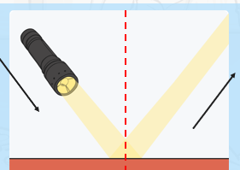  A retro-reflective material reflects all the light towards a person’s eyes. It is used for road signs and safety jackets. | Lesson 3  What 3 properties does something need to have to be good a reflecting light?  Smooth shiny flat  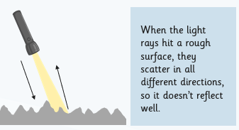  What happens when light hits a rough surface?  What is a mirror?  Mirrors are made of a flat, polished piece of glass with a shiny metal backing, such as silver or aluminium.  The light reflected by a mirror preserves most of the characteristics of the original light, so it creates a clear image.
Lesson 4  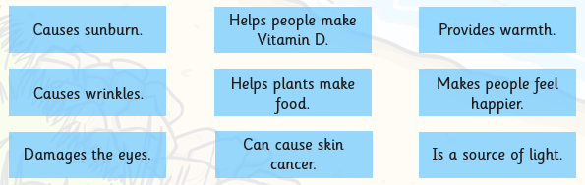  Tick the negative effects of the sun.  Use the word bank to fill in the blanks.  Light spectrum invisible emits rainbow  - The sun ________ rays of light.  - We can’t see all the types of __________ that come from the sun.  - The visible ____________ is name for the light we can see, and it is made up from the colours of the ______________ .  - UV light is ______________ to humans but we can see and feel its effects. | 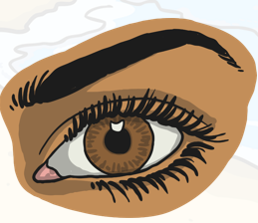  Why must you never look at the sun?  The eye is made to let light in; this is how we see.  Light enters the eye through the pupil. The pupil grows bigger in the dark to let more light in. The eye will get smaller in bright light to let less in.  If too much light comes through the pupil, it can damage the retina.  It causes pain, so that you instantly close your eyes, or turn away from a bright light.  It is very important that you never look directly at the sun, as the light can damage your eyes very quickly.  Bright lights indoors can also damage your eyes, so you should never look at them, or shine lights into anyone's eyes.  You should wear sunglasses when out in the sun. Sunglasses have a UV rating to show how well they block UV rays. Make sure you get sunglasses with a high UV rating. | Lesson 5  What is light?  Complete from the word bank  1) transparent 2) translucent 3) opaque  When the material doesn’t let any light through it is called ___. A material that lets only a little light through is known as __. It is __ when it lets all the light through.  Why do shadows change?

