Long Term Overview: The Reading Journey for Year 3 Theme Genre Author Cross Curricular
 | Autumn 1  7 weeks | Autumn 2  7 weeks | Spring 1  6 weeks | Spring 2  6 weeks | Summer 1  5 weeks | Summer 2  7 weeks
Theme | Fantasy | Being different  Stone Age | Hopes and Dreams | The Power of Nature | Author Study: Anthony Browne | Temptation and Greed
Writing | Poetry: Dragons  Instructional: How to wash a dragon | Narrative: Dialogue  Information texts - | Narrative: A descriptive setting description | Explanation text – Volcanoes  Narrative | Narrative – different viewpoints  Assessment week | Persuasion: Chocolate advert  Narrative characterisation
Writing Journey Text Driver: | 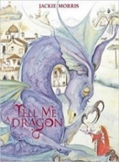  Tell me a Dragon – Jackie Morris  How to Trap a Stone Giant – Pie Corbett | 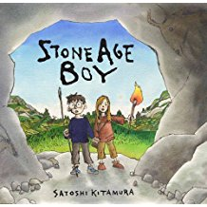  Stone Age Boy  NF texts on Stone Age | The Tin Forest- Helen Ward & Wayne Anderson | National Geographic film of Volcanoes  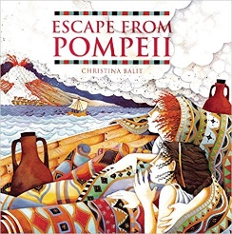  Escape from Pompeii – Christina Balit | 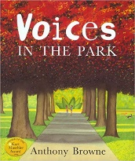  Voices in the Park - Anthony Browne | 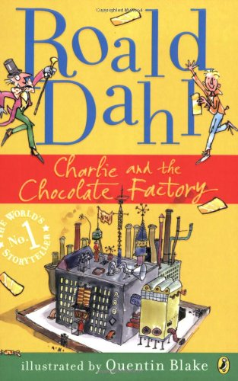  Film and Book
Reading Journey | 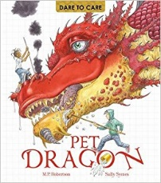  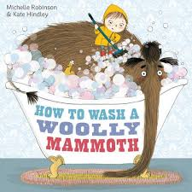  Pet Dragon – Dare to Care | 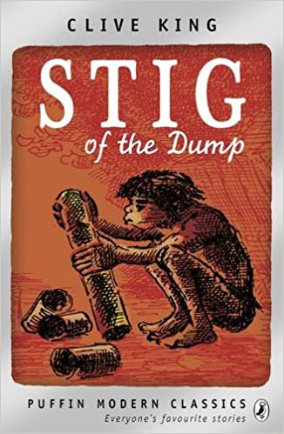  Chapter 1 and TV adaption | 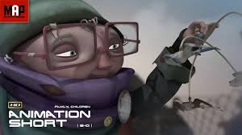  Treasure Short Film | 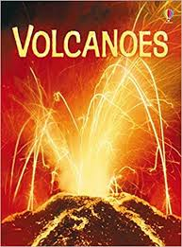  Lava Song – Disney Film | 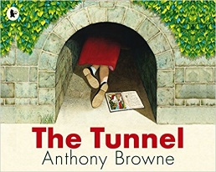  Various Anthony Browne books  + Revision | 