Year 4 ‘Must Read’ Books
To encourage all pupils at MJS to further develop a love of reading, we have put together a list of eight amazing, award-winning books from award-winning authors. The eight books have been carefully selected to include a range of styles and interests. The list will also include classic books that were written a good number of years ago now as this is forms a key part of their reading curriculum. We have also included two non-fiction books linked to the curriculum topics that the children will be learning this year. They will not be expected to have read the non-fiction cover to cover, but we would like them to have spent some time delving in and exploring the information. The pupils have been challenged to read all eight before the end of the year.
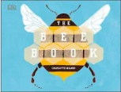
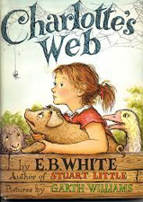
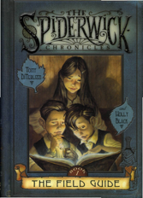
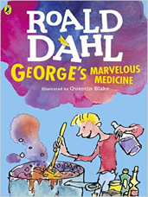
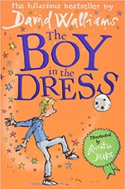
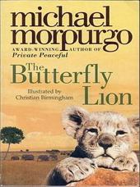
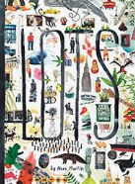
Here are the eight fabulous books that have made the Year 4 List…enjoy listening to your child read them to you, reading them to your child or even reading them at the same time as each other and racing to the finish…

The children can read the books in any order and at the pace they choose.
Whilst every effort has been made to ensure that each book on the list has as wide ranging appeal as possible, it is inevitable that your child will be more enthusiastic about some and less enthusiastic about others but this doesn’t mean they won’t really enjoy the book if they allow themselves to get into it. Many of the books are part of a series so the children can read many more of the ones they enjoy the most
The books vary in level of difficulty but all eight are widely considered to reflect the age related expectation of what children should be reading in Year 4. If your child is finding it hard to read one or more of the books, then they will be encouraged to read parts with a reading partner at school. It would also be really beneficial to them if parts of the book could be read to them at home as well as giving them opportunities to read the book aloud to an adult or sibling. We also have a copy of an audio CD for each book so all children of all abilities can access the story.
Copies of each book are available to the children within school and further copies to read at home will be available, either from the school library or at your local community library. You may of course wish to purchase your own copy of the books.
If you have any questions please speak to your child’s teacher; we’re eager to help.
Enjoy the books and let us know what you think.

