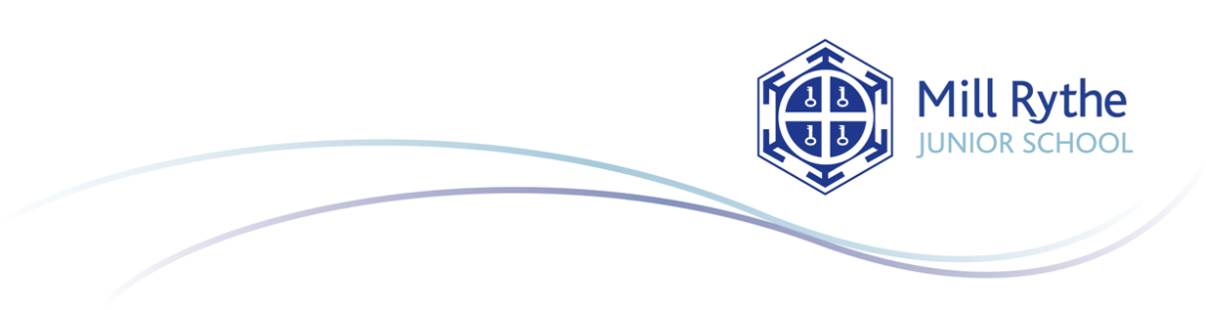

When lining up for the toilets, I will use the crosses on the floor

I will wash my hands with soap and water for at least twenty seconds when I am asked to

I will try hard not touch my face

I will sneeze and cough into a tissue or my elbow and then wash my hands

I will only work and play with children in my bubble

I will stay 2 metres away from others when walking around school and walking on the left

I will tell an adult if I am feeling unwell

I will only bring my water bottle and packed lunch to school each day

I will demonstrate our school values at all times

Social Distancing Behaviour Principles