Home – School
Spelling Bee Challenge

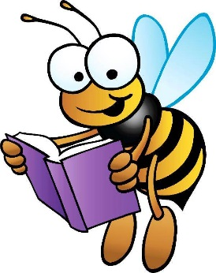
Yellow Booklet - 3

Improve your spelling by learning these words off by heart. Ask somebody at home to sign this booklet, when you are ready to be tested at school. If you get 100% you will get a sticker. Then you can move on to the next booklet.

Name: _______________________________
Class: _______________________________
Date Started: ____ / ____ /_____
Guidance for Parents

Knowing how to spell common words off by heart will make your child more confident with their writing.

Start by going through the spellings with your child. Put the spellings into sentences so that your child understands the meanings of the words. Give lots of praise for the spellings already known and then encourage your child to revisit frequently the ones he/she still needs to learn. (You could get them to test you too!)

Remember, the spellings need to be learned off by heart – use the ‘Look, cover, write, check’ method to help!

When you have learnt them all at home, come and be tested in school!
You will earn a prize each time that you complete a booklet, showing that you can spell all words correctly.

Complete all three booklets for a special reward!

Spelling word | Signed by parent | Date tested in school | Achieved?
physical
programme
recognise
recommend
rhyme
rhythm
shoulder
signature
soldier
sufficient
suggest
symbol
system
twelfth
variety
vehicle
yacht

